February 17, 2012

RefFirst RefLast, RefSuffix
Transmitted Via Fax#: RefFax#

RE: PatFirst PatLast (PatMRN)
DOB: PatDOB

Dear Dr. RefLast:

Thank you kindly for referring PatFirst PatLast to my office for an orthopedic consultation and opinion. Enclosed are my findings.

«TEXT_BODY_VR»
Thank you for allowing me to participate in this very pleasant patient’s care. Should you have any questions regarding the above, please do not hesitate to contact my office.

Sincerely,
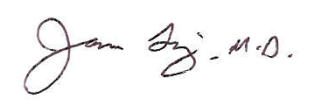
James Ting, M.D.

DicInit:EditID

Dictated but not proofread.

cc:

